Question 1
- Choose one continuous numerical variable from your dataset that you find analytically interesting. In the notebook, compute and display the mean, median, mode, range, and standard deviation for this variable. In a short paragraph, interpret these statistics in the context of your dataset — explain what the mean and standard deviation tell you about the variable's typical value and spread, and state whether the mean or the median is the more appropriate measure of centre given the variable's skewness
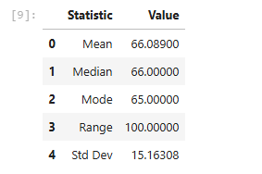
The mean math score is 66.09 and the median is 66.00, which are almost identical, indicating the distribution is fairly symmetric. The standard deviation of 15.16 shows that students' math scores are fairly spread out around this average — most students score somewhere between roughly 51 and 81 (one standard deviation either side of the mean), but the range shows scores stretch further than that at the extremes. Since the mean and median are so close together, and the distribution shows only mild skewness, the mean is an appropriate measure of centre for this variable — it isn't being pulled noticeably by outliers or a long tail, so it fairly represents a "typical" math score in this dataset.

- Using the same variable from part (a), build a well-formatted histogram with exactly eight (8) equalwidth classes. Include a descriptive title and clearly labelled axes (variable name and units on the x-axis; frequency or relative frequency on the y-axis). In a paragraph, describe and interpret the distribution shown: its overall shape (symmetric, positively or negatively skewed, bimodal, or uniform), the approximate centre and spread, and any notable features such as outliers, gaps, or unusual peaks.
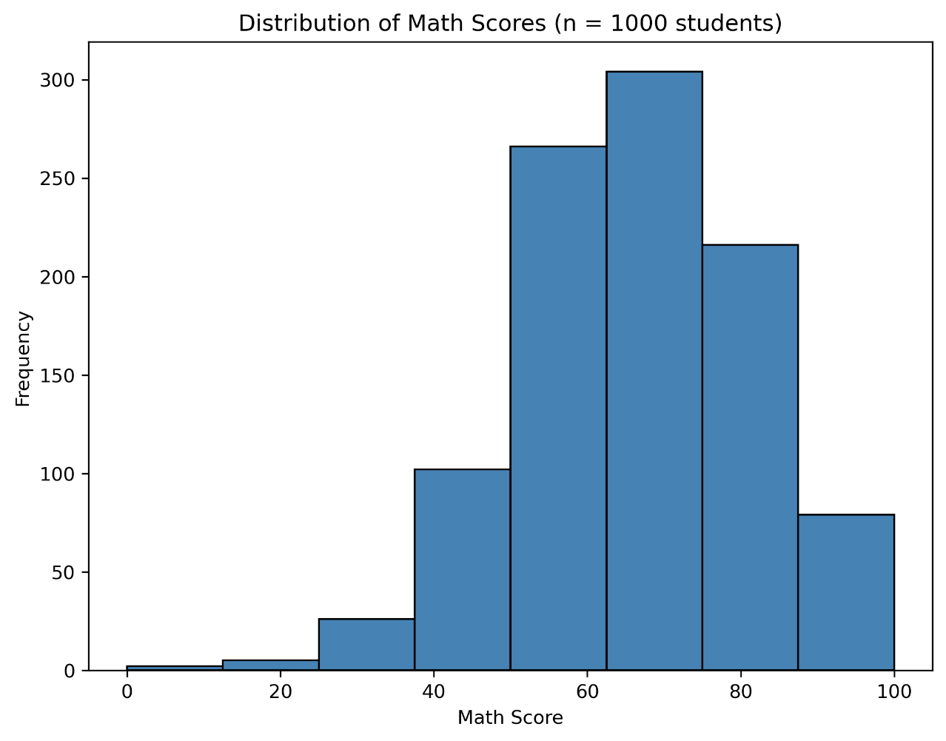

This histogram illustrates how the math scores of 1000 students are distributed among 8 bins of equal width (~12.5 points). The distribution is unimodal with a distinct peak in the range of 62.5 to 75 (over 300 students) followed closely by the next highest bin of 50 to 62.5 (~265 students).

The shape is negatively (left) skewed: there is a long short tail of the bins towards zero (~265 (50-62.5)), followed by moderate-sized bins (slow decrease in size from ~100 (37.5-50) to under 30 (25-37.5) to close to nothing (less than 30) below 25. It is not cut off on the high end, however, as there is a flatter tail in the high end, where the right tail (the high end) is falling off more steeply, but not losing much ground (e.g., top 10% of the students, top bin, ~78 students, scoring 87.5–100). This asymmetry (longer thin tail on the lower score end) is reflected in the mild negative skewness value which was calculated earlier (≈ −0.28) and is the reason for the mean being very slightly lower than where most of the data is clustered (median 66.00 - although visually the peak is nearer to 65-75).

About 78% of students was in between 50 and 87.5 which corresponds to the standard deviation of 15.16. There is no bimodality (one peak is present only) and no gaps between the bars. These low scores (under 25) form a thin tail, which means that they are not an isolated cluster, but rather they have the same distribution as the rest of the scores.

Question 2
- Identify two distinct groups within your dataset that you will compare. These groups must be formed using a categorical variable present in the dataset (e.g., gender, product category, genre, diabetes outcome). State which two groups you are comparing, which numerical variable you are analysing, and provide a brief justification of why this comparison is analytically meaningful in the context of the dataset

Gender is a categorical variable present in the dataset, allowing students to be split into two natural groups: female and male. Comparing math scores between these groups is analytically meaningful because prior educational research has often observed gender-based differences in subject performance, particularly in mathematics. Testing whether such a difference exists in this dataset provides insight into whether performance gaps are present, which can inform discussions around educational equity and targeted support.

b) Construct the 90% confidence interval for the difference in population means. Assume that the population variances are unknown but equal, and that both populations are normally distributed. Your code must clearly show each step: computation of the pooled variance, the standard error, the critical value, and the final interval. Display the lower and upper bounds of the interval.
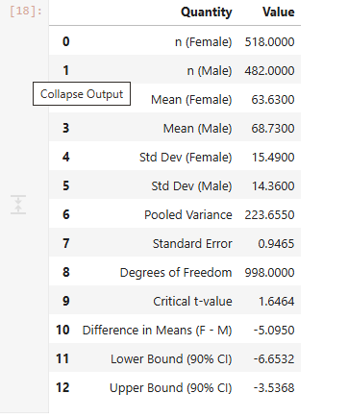
90% Confidence Interval for the difference in mean math scores (Female − Male): (−6.65, −3.54)

- Interpret the confidence interval in the context of the data
The true difference of the means of the math scores for female and male students is between −6.65 and −3.54, with 90% confidence. Since this entire interval is negative (it does not contain zero), it suggests that, on average, female students score lower than male students in math, by somewhere between about 3.5 and 6.65 points. This indicates that there is a true difference in the mean math scores of the two genders and not just due to random variation.

Question 3
a) Using Jupyter Notebook, obtain an output for a hypothesis test at 10% level of significance. The population variances are unknown but assumed to be equal (assume also that the two populations are normally distributed)

